Customize a LappedCircle

Customize a LappedCircle as below:
Notes: Unit is Metric. C3.1415926 is dimension of Circumference and D2 is dimension of diameter and A1 is dimension of Arc.
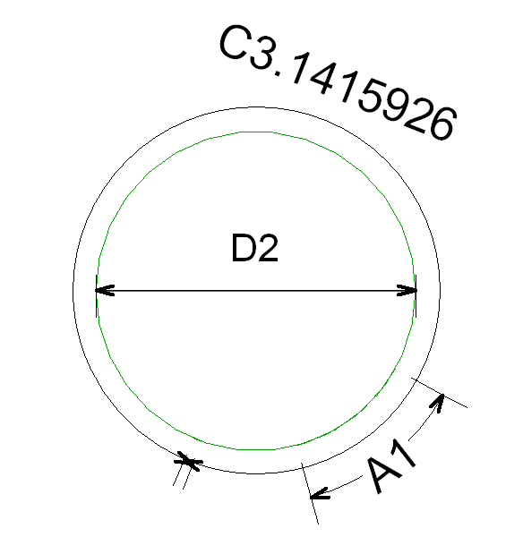

Step by step to define above LappedCircle:
1) Input “MyLappedCircle” as Name and select LappedCircle.
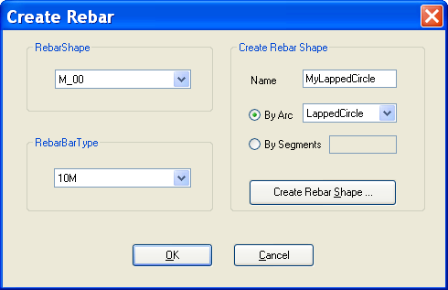

2) After above step, “Create RebarShape” will be presented as below:
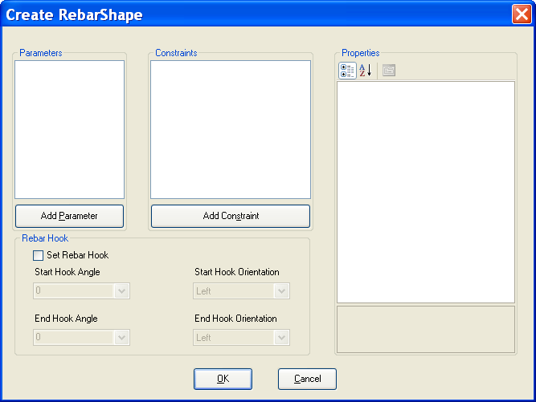

3) Add a double parameter D = 2 as diameter.
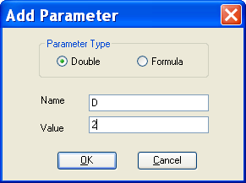

4) Add a double parameter C = 3.1415926 as circumference.
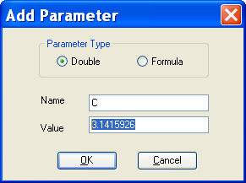

5) Add a double parameter A = 1 as arc length.
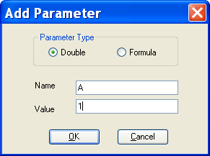

6) After adding three double parameters, the result as below:
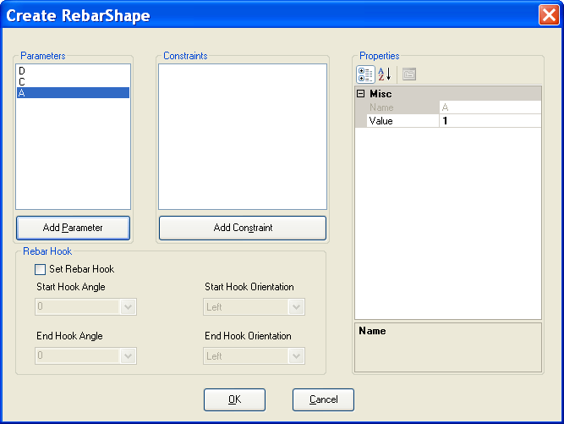

7) Add ConstraintDiameter and initialize its value as below:
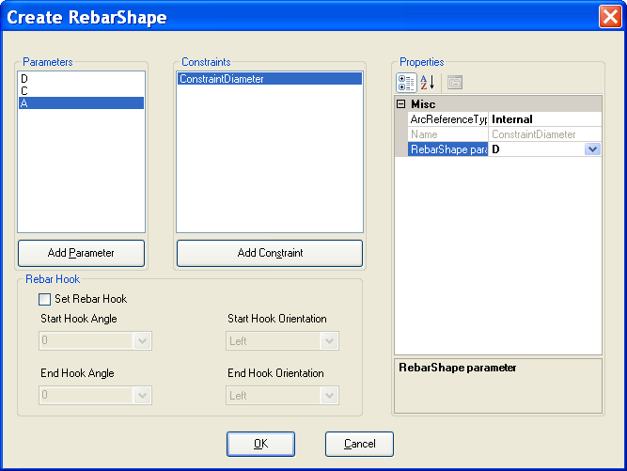

8) Add ConstraintCircumference and initialize its value as below:
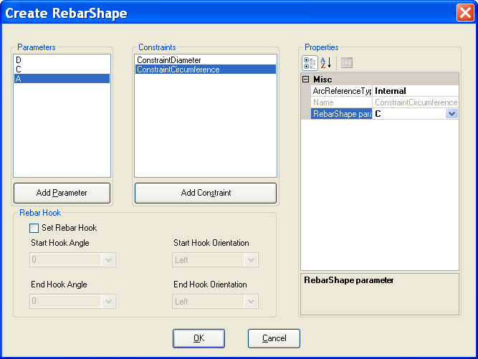

9) Add ConstraintArcLength and initialize its value as below:
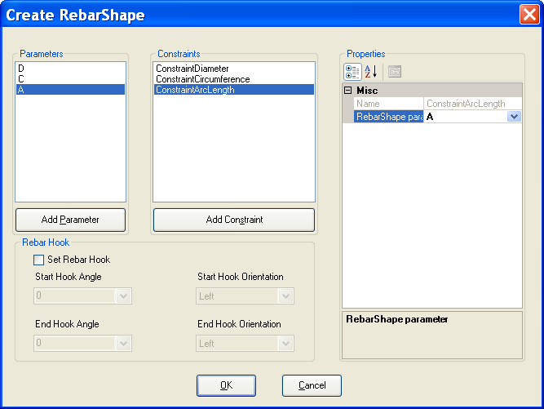

10) Check “Set Rebar Hook” and set hook angle and hook orientation as below:
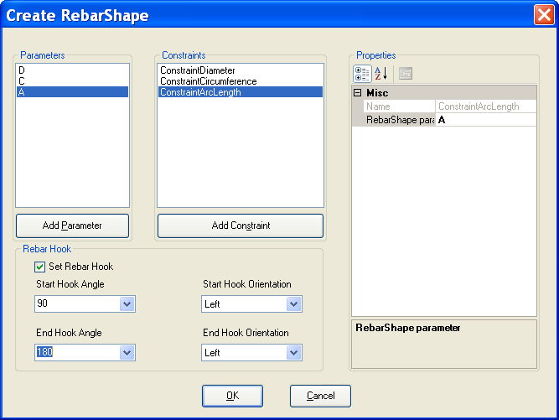

11) After all above steps, “MyLappedCircle” is added to Revit document. And it can be use to create Rebar. Click OK to create a rebar of this shape.
